|  |  |  |  |  |  |
| --- | --- | --- | --- | --- | --- |
| Date | 12-Dec-22 | | | Tester Name | Richard Belanger |
| Environment | Penfax - Test | | | Login used | TEST2 |
| Operating System | Windows | Version: | Update: | | |
| Software Used | Edge | Version: | Update: | | |
| Not Applicable | Version: | Update: | | |
| Release version | 22.4.1 | | | | |
| Title | M51.25 Pay Cycle Update Batch | | | | |
| Test Type | Regression | | | | |
| Test Scenario | Run Pay Cycle Update Batch | | | | |
|  |  | | | | |
| Expected Results | The report will run and display data | | | | |
| Pass/Fail | Pass | | | JIRA# | N/A |

Describe your steps with screenshots:

Set up the Batch

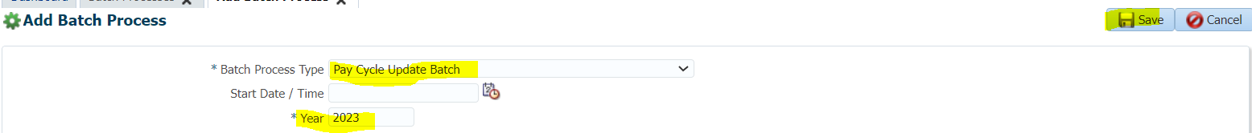

Succeeded

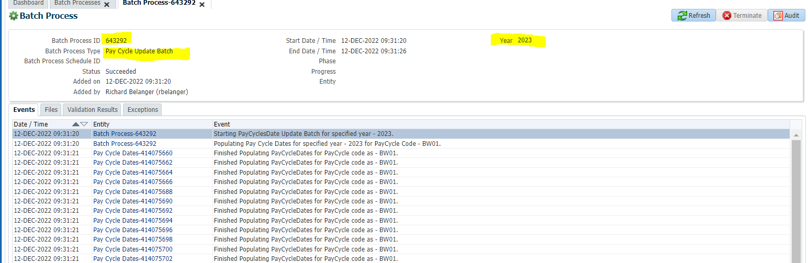

Plan Rules>Pay Cycles

Bi Weekly01

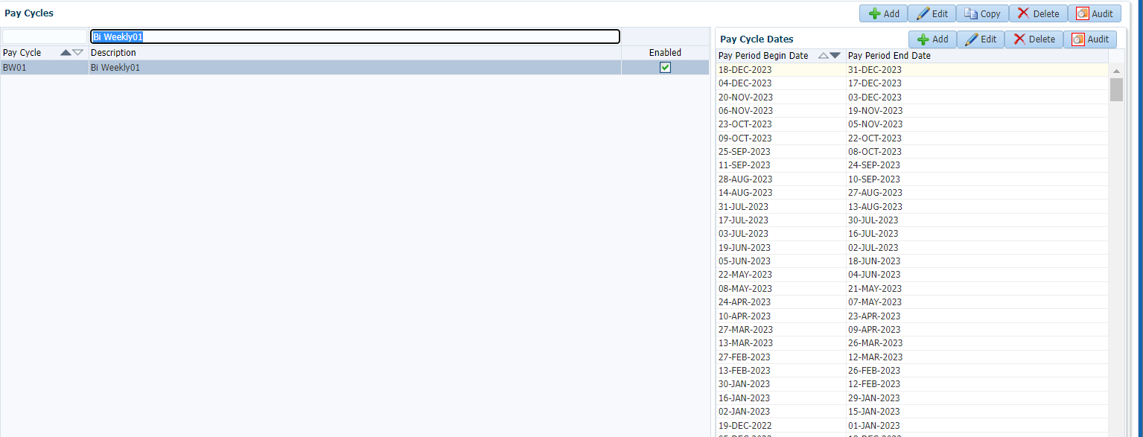

Bi Weekly08

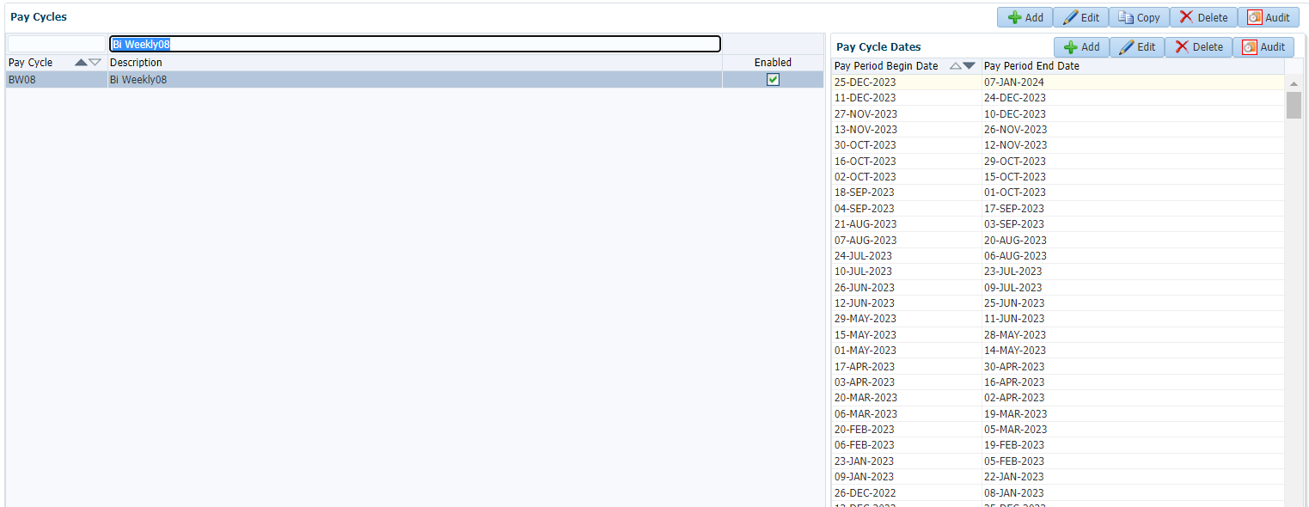

Monthly-Starting 14th

